**STORE SAES ESTIMATION**

***CPSC 531-02, ADVANCED DATABASE SYSTEM***

Project Report

Submitted by: Purva Chakravarti (802344432)

Team Members: Ajinkya Bijwe, Gurpreet Kaur

Guidance:

**Kyong-Seop Shin**

**TABLE OF CONTENTS**

[**1. Introduction 3**](#_Toc418961378)

[**1.1. Problem statement 3**](#_Toc418961379)

[**2. Literature Review: 4**](#_Toc418961380)

[**3. Methodology 5**](#_Toc418961381)

[**3.1. Technical Approach 5**](#_Toc418961382)

[**3.1.1. CSV Files Used 6**](#_Toc418961383)

[**3.1.1.1. Stores.csv 6**](#_Toc418961384)

[**3.1.1.2. Train.csv 6**](#_Toc418961385)

[**3.1.1.3. test.csv 6**](#_Toc418961386)

[**3.1.1.4. features.csv 6**](#_Toc418961387)

[**3.1.2. About Packages imported in the project 7**](#_Toc418961388)

[**3.1.2.1. TimeDate: 7**](#_Toc418961389)

[**3.1.2.2. Randomforest: 7**](#_Toc418961390)

[**3.1.2.2.1. Working of RandomForest: 11**](#_Toc418961391)

[**3.2. Proposed Methodology 12**](#_Toc418961392)

[**4. Discussion 12**](#_Toc418961393)

[**5. Results 13**](#_Toc418961394)

[**6. Implications 13**](#_Toc418961395)

[**6.1. Benefit 13**](#_Toc418961396)

[**6.2. Assumptions, Limitations, Future scope 13**](#_Toc418961397)

[**7. Conclusions: 14**](#_Toc418961398)

[**8. Appendix: 14**](#_Toc418961399)

[**8.1. Download and install these softwares: 14**](#_Toc418961400)

[**8.2. User Manual 14**](#_Toc418961401)

[**9. References 14**](#_Toc418961402)

**TABLE OF FIGURES:**

[*Figure 1: Needs and possibilities of KDD* *(Maimon & Rokach, n.d.)* 4](#_Toc418975821)

[*Figure 2: Snapshot of the final.csv file stored in the folder* 7](#_Toc418975822)

[*Figure 3: highest sale final output* 7](#_Toc418975823)

[*Figure 4: Snapshot of stores.csv* 8](#_Toc418975824)

[*Figure 5 Snapshot of train.csv* 9](#_Toc418975825)

[*Figure 6 Snapshot of test.csv* 10](#_Toc418975826)

[*Figure 7: Snapshot of features.csv* 11](#_Toc418975827)

[*Figure 8 snapshot of sampleoutput.csv* 11](#_Toc418975828)

[*Figure 9: Snapshot of final.csv* 19](#_Toc418975829)

[*Figure 10: platform requirements* 21](#_Toc418975830)

[*Figure 11: Snapshot for clicking on makesubmission.R* 21](#_Toc418975831)

[*Figure 12: Randomforest and timedate installation window* 22](#_Toc418975832)

[*Figure 13: Packages installed successfully* 22](#_Toc418975833)

[*Figure 14: Decision tree formation* 23](#_Toc418975834)

[*Figure 15: Final output window* 24](#_Toc418975835)

**ABSTRACT**

Sales estimation means predicting the sales for a certain period depending on the historical data of the store. The sales prediction establishes the level of activity used in all the other forecasts and budgets for the business. If the sales forecast varies wildly from the actual results, the cash flow and profitability forecasts will similarly be inaccurate. The entire sales forecasting process is intended to generate better business results from better business decisions. So what really matters is whether or not the sales forecast is set up right and broken into factors which we will be able to track and will lead to better management decisions.

The main objective of this project is to analyse the historical sales data available for many departments of a store by exploring different data mining techniques. The datasets will undergo through various data mining tasks such as survey analysis, training the model using the dataset and prediction of knowledge using proper logic. Different data mining tasks, techniques and tools will be used for the sales estimation from the extracted data of the dataset.

# **Introduction**

The most important thing in retail is to continue satisfying customer needs and their demands. As seen in today’s world competition is increasing and so is the expectations of customers. This project introduces the concept of data mining in this process. The concept behind this project is to increase the sales by analysing and keeping track of customer’s habits. This activity is known as “Knowledge Discovery in Database”. The motive of this project is to increase the sales by using data mining techniques and KDD steps. This includes algorithm of Randomforest in order to provide best analysis

# **Problem statement**

The sales of a particular store has gone bad. It depends on the quality, quantity and the prices which are available at the store. There are various discounts to be added in order to improve the sales. The store needs a proper plan about how the sales should be increased and improved. They need to find special occasions to implement, it may be its holidays or special days. For implementation of this, it is essential to look for the historical data in respective departments of the company.

The holiday markdown events are included. It is very important to note down the effects of holiday markdown events and particularly how they effect it. In this project the effect and impact of every holiday is marked and analysed. The lack of awareness and prediction techniques may cause failure in the sales. So our project provides a sales estimation to avoid the causes of failure and give chances to make any improvement if needed. It also looks towards how to increase the profit rate.

# **Literature Review:**

The knowledge data discovery process is processed in nine steps. This process is iterative and in each step going back might occur

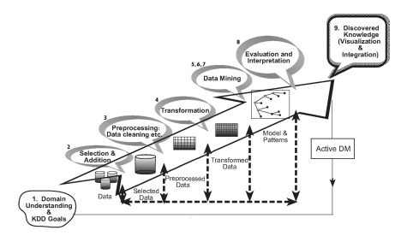

*Figure 1: Needs and possibilities of KDD* *(Maimon & Rokach, n.d.)*

There are different needs and possibilities at each step of this process. The entire structure of the process as shown in the Figure1.

According to the first step of the Knowledge Data Discovery process we have to develop and understand the application domain. This is a very initial process which prepares the system for further steps. In this process the goals of the application are decided. So, we first came up with the problem statement and the techniques to solve it. After understanding the problem statement, the pre-processing of data is started.

The second step is to select and create the dataset on which the discovery is to be operated which we have obtained from KDD website for our project. It includes the training set, test set, features set. In this step, the availability of data is also decided, which type of data is required and then all the data is integrated into one data set which includes all the important attributes of this data. In this all the attributes should be present if not then the entire process can collapse. Here we created a “data” folder and kept all the files in it.

The third step is the pre-processing and cleansing. In this particular step the data mishandling is improved. If there are certain values which are missing they are cleared and the entire data set is to be cleaned. We have some missing data in the marked down events where we have mentioned NA.

The fourth step of this process is data transformation. This step includes cropping out some irrelevant data which is not useful. This step is essential because it is providing the specifications for the entire KDD process. We truncated the data we got from KDD site to 50% as it was very difficult to run such a big file which consists of 128mb size, having a RAM of 2GB.

The fifth step is to choose the appropriate data mining task. After so much of filtering the process is ready to choose its data mining task which should be appropriate for the particular process. The objectives of this step is prediction and description. For this we have chosen randomforest package and the timedate package which uses the Breiman’s algorithm for classification and regression. It is actually based on the following three concepts:

* Decision tree
* Tree bagging
* From Bagging to Random forest

The sixth step is to choose the data mining algorithm. Before this step the strategy has been made and now the task is to make tactics. This might include finding the searching method for process or may be the technique to search.

The Seventh step is to employ the data mining algorithm. This includes the implementation of the data mining algorithm which is decided in sixth step. This step might include the iteration of that algorithm just to make sure its validity and efficiency.

The eight step is to evaluate. In this step the evaluation of the pattern is done. It keeps a track of fulfilling the goals of the project and maintaining its efficiency. This step specifies the usefulness and the efficiency of the pattern used. The discovered knowledge is documented for the further use of the system.

The ninth and the last step of this process is to use the discovered knowledge. This step makes it useful for the knowledge discovered for the further purpose. This step also includes the changes made into data and noticing its effects in the system. Hence, this way the KDD process is completed in its nine stages. (Maimon & Rokach, n.d.)

# **Methodology**

The problem solution is written in R programming. R is a tool for statistics and data modelling. The R programming language is elegant, versatile, and has a highly expressive syntax designed around working with data. R is more than that, though — it also includes extremely powerful graphics capabilities. (code school, n.d.).R is a free software environment for statistical computing and graphics. It compiles and runs on a wide variety of UNIX platforms, Windows and MacOS. (The R foundation, n.d.)

The backend or the database proposed for the solution will be achieved by the use of CSV. CSV is a common file format that is widely supported by consumer, business, and scientific applications. Among its most common uses is moving tabular data between programs that natively operate on incompatible (often proprietary and/or undocumented) formats. (wikipedia, 2015).The so-called CSV) format is the most common import and export format for spreadsheets and databases. There is no “CSV standard”, so the format is operationally defined by the many applications which read and write it. (wikipedia, 2015)

The dataset for this problem is acquired from KDD. KDD (Knowledge Discovery in Database) is modelling and analysis of the large data repositories. The data mining is the basis for KDD, involving construction of the algorithm, developing the model for unknown pattern and predict the useful solution with the help of suitable logic. (Maimon & Rokach, n.d.)

# **Technical Approach**

The editor for R programming and R studio is used for the programming purpose.

R Studio is a free and open source integrated development environment (IDE) for R, a programming language for statistical computing and graphics.

R Studio Desktop, where the program is run locally as a regular desktop application; and

CSV files can be viewed in Microsoft Excel or CSVed. CSVed 2.3.2 is the latest version of CSVed. It is an easy and powerful CSV file editor, you can manipulate any CSV file, separated with any separator.

The project while building we divided into namely 4 modules:

1. Importing the Data from the CSV files and packages.

In this we have imported 5 csv files from the KDD website. We added the packages Randomforest and TimeDate by library (package\_name) command.It can be imported once we installed them. The dataset is imported into the program by read.csv command in the R language. The all csv files are stored into the data folder of the project. The logic code is stores in the R folder with the .R extension. The program code imports these files and proceed to the next step. Each of these files are narrowed down to some space so as the limited memory of the system. Each file brought down to the size of maximum of 1.4 MB

1. Storing the values into the temporary variables;

We have used the temporal variables dftrain, dfeatures, dftest, dfstore, dfsample for storing of the csv datasets. We have taken the values such as department id, store id, historical sales, date and holiday Boolean value and stored it in temporary variable. In the later part of the program is run to extract the final data.

1. Applying the RandomForest algorithm.

The RandomForest is included in the program by library(randomForestC:\Users\Ajinkya\AppData\Local\Temp\x10sctmp7.png) at the start of the program if the package is not installed properly the program will come to halt.

We have created decision trees. In the Random Forest algorithm each tree is determined from the proximity matrix and when the two trees in the algorithm are related it is said to be the forest. Random Forests grows many classification trees. To classify a new object from an input vector, put the input vector down each of the trees in the forest. Each tree gives a classification, and we say the tree "votes" for that class (Breiman & Cutler)Refer Figure: 14

1. Writing the output in the Final.csv file.

After the execution of the model with the given csv files and after the proximity calculation the program will store the output in the final folder of the project folder by the name of Final.csv file as shown in Figure: 2

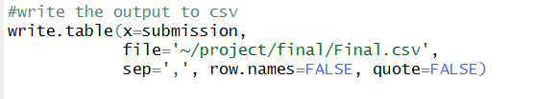

*Figure 2: Snapshot of the final.csv file stored in the folder*

The output is written in the file with the write.table() function. In the arguments of this function the path where the file is to be stored provided and the separator (,) is given to separate the output values. Refer Figure: 3

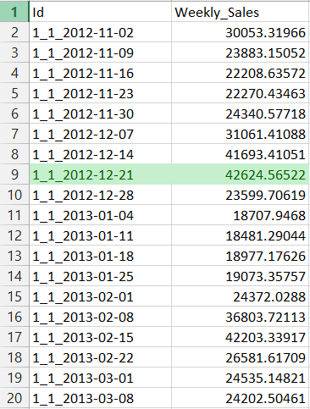

*Figure 3: highest sale final output*

# Imported .csv files

We imported the following csv files during the project building.

# **Stores.csv**

This file contains anonymized information about the store, indicating the type and size of store. Refer Figure: 4

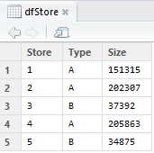

*Figure 4: Snapshot of stores.csv*

# Train.csv

This is the historical training data, which covers to 2010-02-05 to 2012-11-01. This file contains the following fields:

* Store - the store number
* Dept - the department number
* Date - the week
* Weekly\_Sales - sales for the given department in the given store
* IsHoliday - whether the week is a special holiday week

Refer Figure:5

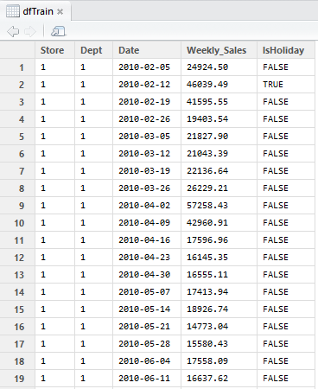

*Figure 5 Snapshot of train.csv*

# Test.csv

This file is identical to train.csv, except we have withheld the weekly sales. We predicted the sales for each triplet of store, department, and date in this file. Refer Figure: 6

***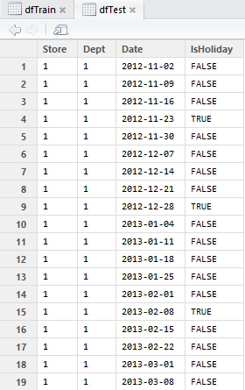***

*Figure 6 Snapshot of test.csv*

# Features.csv

This file contains additional data related to the store, department, and regional activity for the given dates. It contains the following fields:

* Store - the store number
* Date - the week
* Temperature - average temperature in the region
* Fuel\_Price - cost of fuel in the region
* MarkDown1-5 - anonymized data related to promotional markdowns that Walmart is running. MarkDown data is only available after Nov 2011, and is not available for all stores all the time. Any missing value is marked with an NA.
* CPI - the consumer price index
* Unemployment - the unemployment rate
* IsHoliday - whether the week is a special holiday week

For convenience, the four holidays fall within the following weeks in the dataset (not all holidays are in the data):

* Super Bowl: 12-Feb-10, 11-Feb-11, 10-Feb-12, 8-Feb-13
* Labour Day: 10-Sep-10, 9-Sep-11, 7-Sep-12, 6-Sep-13
* Thanksgiving: 26-Nov-10, 25-Nov-11, 23-Nov-12, 29-Nov-13
* Christmas: 31-Dec-10, 30-Dec-11, 28-Dec-12, 27-Dec-13

Refer Figure: 7

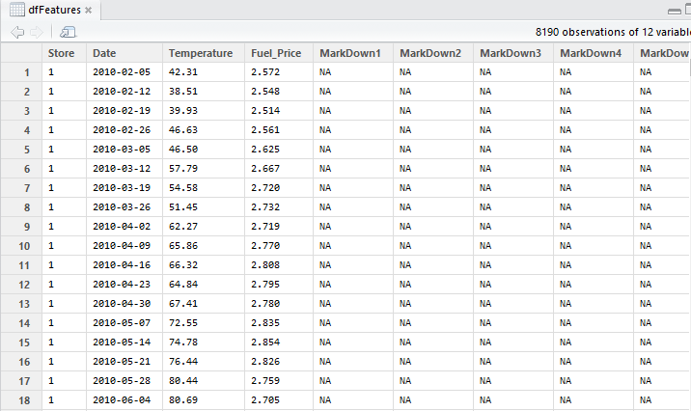

*Figure 7: Snapshot of features.csv*

# 3.1.1.5. Sampleoutput.csv

The above file contains how the format of the final output should be. The format to store the data to this file is written as storeid\_departmentid\_date format in the id column of the SampleOutput.csv file whereas the amount of the sales are weekly\_sales will be the final output i.e. amount of the sales. The output of the output Final.csv file will range from date 2nd of November 2012 to 26th July 2013. Refer Figure: 8

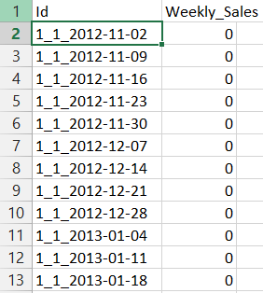

*Figure 8 snapshot of sampleoutput.csv*

# About Packages imported in the project

# TimeDate:

* Description: Create a ’timeDate’ object from scratch using a

character vector.

* Usage: timeDate(charvec, format = NULL, zone

= "", FinCenter = "")

strptimeDate(x, format = whichFormat(x), tz = "")

* Arguments:

Charvec: a character string or vector of dates and times.

Format: the format specification of the input character vector.

Tz: a character with the location of the financial centre named as "continent/city", or short "city".

Zone: the time zone or financial centre where the data were recorded.

X : a character string or vector of dates and times.

FinCenter: a character with the the location of the financial centre named as "continent/city".

* Value: returns an object of class timeDate.

# Randomforest:

* Description: Classification and regression based on a forest of

trees

* Implementation: randomForest implements Breiman’s random

forest algorithm (based on Breiman and Cutler’s original Fortran code) for classification and regression. It can also be used in unsupervised mode for assessing proximities among data point

* Usage: ## S3 method for class 'formula'

randomForest(formula, data=NULL, ..., subset, na.action=na.fail)

## Default S3 method:

randomForest(x, y=NULL, xtest=NULL, ytest=NULL, ntree=500,

mtry=if (!is.null(y) && !is.factor(y))

max(floor(ncol(x)/3), 1) else floor(sqrt(ncol(x))),

replace=TRUE, classwt=NULL, cutoff, strata,

sampsize = if (replace) nrow(x) else ceiling(.632\*nrow(x)),

nodesize = if (!is.null(y) && !is.factor(y)) 5 else 1,

maxnodes = NULL,

importance=FALSE, localImp=FALSE, nPerm=1,

proximity, oob.prox=proximity,

norm.votes=TRUE, do.trace=FALSE,

keep.forest=!is.null(y) && is.null(xtest), corr.bias=FALSE, keep.inbag=FALSE, ...) ## S3 method for class 'randomForest' print(x, ...)

* Arguments:

Data: an optional data frame containing the variables in the model. By default the variables are taken from the environment which randomForest is called from.

Subset: an index vector indicating which rows should be used. (NOTE: If given, this argument must be named.)

na.action A function to specify the action to be taken if NAs are found. (NOTE: If given, this argument must be named.)

x, formula a data frame or a matrix of predictors, or a formula describing the model to be fitted (for the print method, an randomForest object).

Y A response vector. If a factor, classification is assumed, otherwise regression is assumed. If omitted, randomForest will run in unsupervised mode.

xtest a data frame or matrix (like x) containing predictors for the test set.

ytest response for the test set.

ntree Number of trees to grow. This should not be set to too small a number, to ensure that every input row gets predicted at least a few times.

Mtry Number of variables randomly sampled as candidates at each split. Note that the default values are different for classification

(sqrt(p) where p is number of variables in x) and regression (p/3) replace Should sampling of cases be done with or without replacement?

classwt Priors of the classes. Need not add up to one. Ignored for regression.

Cutoff (Classification only) A vector of length equal to number of classes. The ‘winning’ class for an observation is the one with the maximum ratio of proportion of votes to cutoff. Default is 1/k where k is the number of classes (i.e., majority vote wins).

strata A (factor) variable that is used for stratified sampling.

sampsize Size(s) of sample to draw. For classification, if sampsize is a vector of the length the number of strata, then sampling is stratified by strata, and the elements of sampsize indicate the numbers to be drawn from the strata.

nodesize Minimum size of terminal nodes. Setting this number larger causes smaller trees to be grown (and thus take less time). Note that the default values are different for classification (1) and regression (5).

maxnodes Maximum number of terminal nodes trees in the forest can have. If not given, trees are grown to the maximum possible (subject to limits by nodesize). If set larger than maximum possible, a warning is issued.

importance Should importance of predictors be assessed?

localImp Should casewise importance measure be computed? (Setting this to TRUE will override importance.)

nPerm Number of times the OOB data are permuted per tree for assessing variable importance. Number larger than 1 gives slightly more stable estimate, but not very effective. Currently only implemented for regression.

proximity Should proximity measure among the rows be calculated?

oob.prox Should proximity be calculated only on “out-of-bag” data?

norm.votes If TRUE (default), the final result of votes are expressed as fractions. If FALSE, raw vote counts are returned (useful for combining results from different runs). Ignored for regression.

do.trace If set to TRUE, give a more verbose output as randomForest is run. If set to some integer, then running output is printed for every do.trace trees.

keep.forest If set to FALSE, the forest will not be retained in the output object. If xtest is given, defaults to FALSE.

corr.bias perform bias correction for regression? Note: Experimental. Use at your own risk.

keep.inbag Should an n by ntree matrix be returned that keeps track of which samples are “in-bag” in which trees (but not how many times, if sampling with replacement)

... optional parameters to be passed to the low level function randomForest.default. randomForest 19

* **Value** An object of class randomForest, which is a list

with the following components:

call the original call to randomForest

type one of regression, classification, or unsupervised.

predicted the predicted values of the input data based on out-of-bag samples.

importance a matrix with nclass + 2 (for classification) or two (for regression) columns. For classification, the first nclass columns are the class-specific measures computed as mean descrease in accuracy. The nclass + 1st column is the mean descrease in accuracy over all classes. The last column is the mean decrease in Gini index. For Regression, the first column is the mean decrease in accuracy and the second the mean decrease in MSE. If importance=FALSE, the last measure is still returned as a vector.

importanceSD The “standard errors” of the permutation-based importance measure. For classi-fication, a p by nclass + 1 matrix corresponding to the first nclass + 1 columns of the importance matrix. For regression, a length p vector.

localImp a p by n matrix containing the casewise importance measures, the [i,j] element of which is the importance of i-th variable on the j-th case. NULL if localImp=FALSE.

ntree number of trees grown.

mtry number of predictors sampled for spliting at each node.

forest (a list that contains the entire forest; NULL if randomForest is run in unsupervised mode or if keep.forest=FALSE.

err.rate (classification only) vector error rates of the prediction on the input data, the i-th element being the (OOB) error rate for all trees up to the i-th. confusion (classification only) the

confusion matrix of the prediction (based on OOB data).

votes (classification only) a matrix with one row for each input data point and one column for each class, giving the fraction or number of (OOB) ‘votes’ from the random forest.

oob.times number of times cases are ‘out-of-bag’ (and thus used in computing OOB error estimate)

proximity if proximity=TRUE when randomForest is called, a matrix of proximity measures among the input (based on the frequency that pairs of data points are in the same terminal nodes).

mse (regression only) vector of mean square errors: sum of squared residuals divided by n.

rsq (regression only) “pseudo R-squared”: 1 - mse / Var(y).

test if test set is given (through the xtest or additionally ytest arguments), this component is a list which contains the corresponding predicted, err.rate, confusion, votes (for classification) or predicted, mse and rsq (for regression) for the test set. If proximity=TRUE, there is also a component, proximity, which contains the proximity among the test set as well as proximity between test and training data. (Breiman, Cutler, Liaw, & Wiener, 2015)

# Working of RandomForest:

Algorithm

Decision tree learning:

Trees that are grown very deep tend to learn highly irregular patterns. They [overfit](http://en.wikipedia.org/wiki/Overfitting" \o "Overfitting) their training sets, because they have [low bias, but very high variance](http://en.wikipedia.org/wiki/Bias%E2%80%93variance_tradeoff). Random forests are a way of averaging multiple deep decision trees, trained on different parts of the same training set, with the goal of reducing the variance. This comes at the expense of a small increase in the bias and some loss of interpretability, but generally greatly boosts the performance of the final model.

Tree bagging:

The training algorithm for random forests applies the general technique of bootstrap aggregating, or bagging, to tree learners. Given a training set *X* = *x1*, …, *xn* with responses *Y*= *y1*, …, *yn*, bagging repeatedly selects a random sample with replacement of the training set and fits trees to these samples:

For *b* = 1, …, *B*:

* Sample, with replacement, *n* training examples from *X*, *Y*; call these *Xb*, *Yb*.
* Train a decision or regression tree *fb* on *Xb*, *Yb*.

After training, predictions for unseen samples *x'* can be made by averaging the predictions from all the individual regression trees on *x'*:

\hat{f} = \frac{1}{B} \sum_{b=1}^B \hat{f}_b (x')

or by taking the majority vote in the case of decision trees.

From bagging to random forests

The above procedure describes the original bagging algorithm for trees. Random forests differ in only one way from this general scheme: they use a modified tree learning algorithm that selects, at each candidate split in the learning process, a random subset of the features. This process is sometimes called "feature bagging". The reason for doing this is the correlation of the trees in an ordinary bootstrap sample: if one or a few features are very strong predictors for the response variable (target output), these features will be selected in many of the *B* trees, causing them to become correlated.

Typically, for a dataset with *p* features, √*p* features are used in each split. (Wikipedia, 2015)

# **Proposed Methodology**

The proposed methodology for the problem solution is the quantitative approach. This will include maintaining the validity of the data sets, for this the data set will be required to be updated periodically. Updating the data sets will help us maintaining the accuracy of the predictions or the results.

# **Discussion**

While analysing the data set we found that holidays in the store should be used to create distribution of sales. For each holiday, based on their date, we found with 3 parameters namely, width, skew and location (relative to the actual date) are need to be considered. We made these distributions on a daily grid and then sum them up to weekly totals. Using skewed distributions was a key here for us. We largely fit the parameters by eye to begin with.

For each store/department combination, after calculating the trend in the data, we used a linear model with L1 regularization to fit the holidays to the distended data. Then after subtracting the holiday fit and trend, we took an average of value for the week over the years to find the residual weekly cycle that was not due to the holidays.

Then we also fit the trend + de-seasonalized data using the Unemployment, Fuel Price and CPI, using another linear model with L1 regularization. We also calculated the missing data using a simple AR model. This fit will give a small improvement over using the pure trend.

We used csv over the first two years / last 39 weeks split to pick whether the trend was constant or linear. For example something happened at store 5, which caused a dramatic drop in sales across all departments, so we applied a step function to account for this.

The dataset used here is acquired from KDD which provided us with a large volume of inputs to analyse and provide accurate estimates. As this is a solution to provide forecast or predictions we require a large dataset, getting a dataset from KDD was very useful.

# **Results**

We found that since we only have 1 year of markdown data in the dataset it is impossible to extract anything much useful from it, as we could not see the effect from one year to the next. But the output which is predicted by our project was enough to get the accuracy of the sales of the respective departments in the store for the year that is 2012 to 2013.

The prediction shows that there is high sale mostly in the holiday weeks than the weeks.

The proposed sales are 88% accurate according to algorithm execution. The accuracy can be increased further by taking multiple features while calculation the random forest. We can use this logic for defining various statistical analysis too. Refer Figure: 9

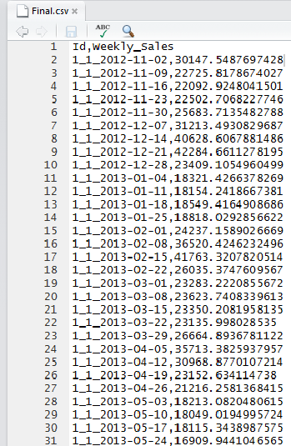

*Figure 9: Snapshot of final.csv*

# **Implications**

# **Benefit**

The benefits of using Knowledge Discovery in Database is that we got the proper judgement of the increment in sales, keeping the customers happy, efficiently obtaining the goals. This also includes the design of a pattern on which the activity should be working.

The store is to be analysed by considering different occasions and by considering different conditions like weather, fuel etc. This is beneficial in maintaining the inventory of the store and providing the customers the product they want. This is also helpful in maintaining the image and the brand value of the store. If the store needs some changes then it can even do it by following the pattern.

Moreover, the store manager can also manage profit multiple departments by providing the markdown sales on the prices of the goods on that specific department. The store managers and the multiple sales person can also model their sales and markdown events which can help them to thrive in their business with regards to profit in the sales.

# **Assumptions, Limitations, Future scope**

For example, if we consider animals they look for food with some kind of assumptions. Similarly a data analyst will also make assumptions for a task to be executed. (Murray & Gardiner, n.d.) This based on assumptions of sales using historical data and analysing it for mining purposes.

The limitations of this process may be considered as the availability of data. The data available is huge which affects the processing time. It takes more than a day to execute if we take the complete sets of data available. It is possible to execute fast such kind of programs if they can be implemented on the server and not in the personal laptops. It needs high processing CPU and storage capacity. 2GB RAM is not at all sufficient to run fast such kind of huge data.

The future scope of our project is we can implement it for huge data if we have such a big platform to work with.

# **Conclusions:**

In this report we have discussed about the sampling and extraction of features from the dataset we have used. We analysed the dataset and from the feature extraction we have compiled the final output that is the prediction of sales for the year 2012-2013 depending on the datasets of 2010-2012.In this we mainly used data mining during feature extraction and discussed how the KDD final data extraction model work in the real time. We have imported the sample datasets in the program for the prediction. We have also discussed about the working of RandomForest algorithm during the calculation of the proximity values and the final values. The maximum efficiency and accuracy with regards to the calculation of the final values of the store sales was best obtained from RandomForest. We have also used the TimeDate package for getting dates and timestamps. The final result of this logic are the future values of the sales whose accuracy can be increased by proposing the better feature values to the logic. Finally we found out that this logic can benefit the store manager to maximize the profit of the sales by giving certain markdown events in the year.

# **Appendix:**

# **Download and install these software from the URL link provided:**

* R studio

URL: <http://www.rstudio.com/products/rstudio/download/>

* R-3.1.3

URL: <http://cran.r-project.org/mirrors.html>

# **Platform Requirements**:

|  |  |
| --- | --- |
| Hardware Requirement: | Software Requirements: |
| RAM: 4GB minimum  Hard disk: 512 MB  Operating system: Windows(any),Mac, Linux  Internet: Needed | R programming Language 32/64bit.  R studio 32/64bit for Windows/Mac OSX/Linux.  Microsoft Excel for reading .csv files. |

*Figure 10: platform requirements*

# **User Manual**

Steps to be taken:

* Copy the code folder with the csv files in the C:/ Documents folder for easy access.
* After installation open R Studio and R programming language, look for the code folder in the right down-corner under the “home”.
* Make sure that the code folder contains all the csv files inside “data” folder.
* Double click on the code folder and click on the project.Rproject
* Go to the R folder present inside the code folder.
* Double click on it.
* Look for the makeSubmission.R file.

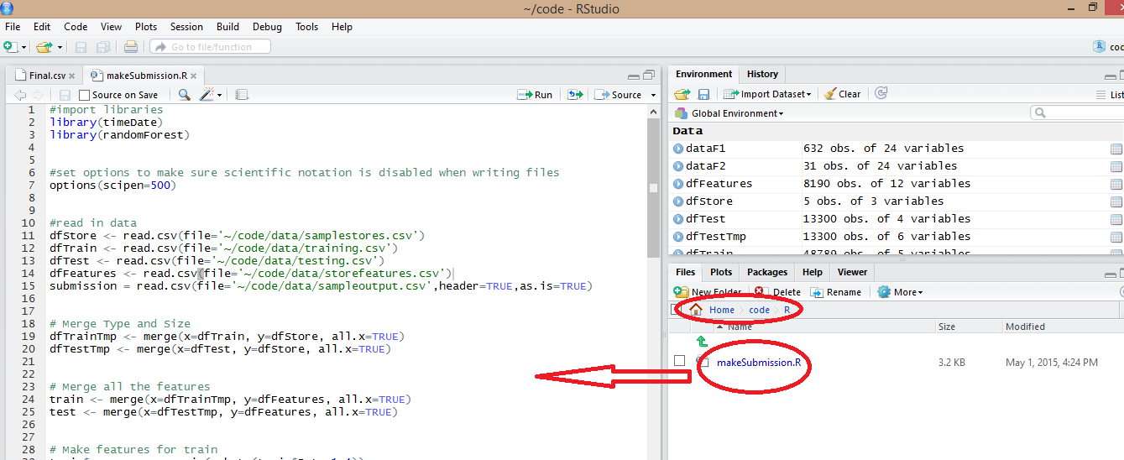

*Figure 11: Snapshot for clicking on makesubmission.R*

* Click on it. It will appear in the left side editing window as shown in the Figure: 11
* Press CTRL+A Click on Code>Run region>Run all from the tool bar
* The execution window will show it execution as started.
* It will encounter an error like randomforest package and timedate package is not available.
* Install the packages form the “Tools” in the toolbar by selecting Tools>>Install Packages make sure the system have the internet connection to install the packages
* You can also install it by direct clicking on the package folder present on the right hand corner of the window(as shown in Figure:12)
* Click on the checkbox for RandomForest and TimeDate as shown in the Figure:12

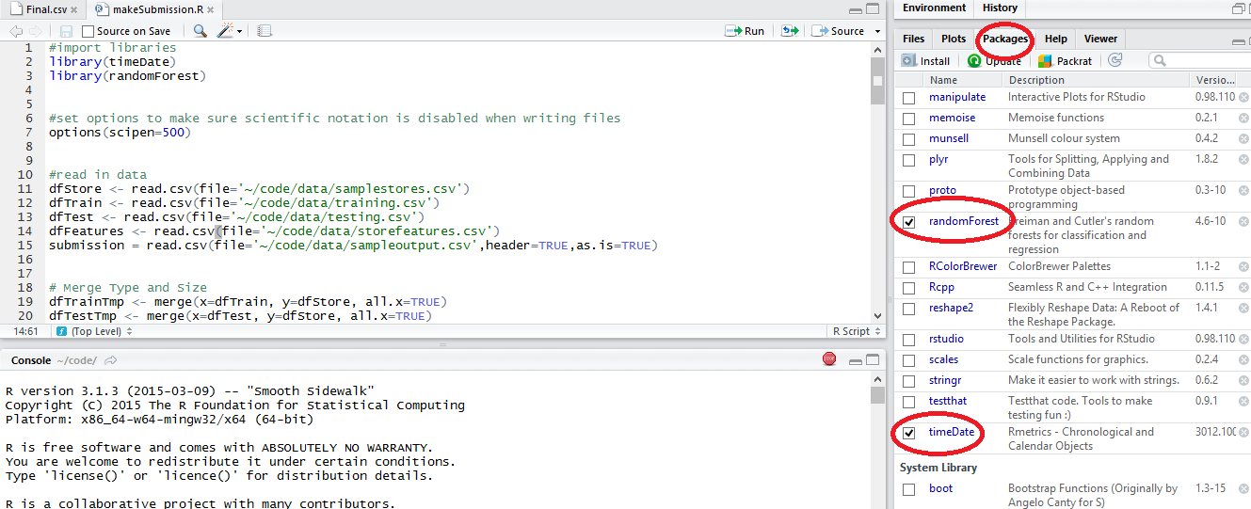

*Figure 12: Randomforest and timedate installation window*

* Type in the name of the packages required to install “TimeDate,RandomForest” both the packages must be separated by comma “,”. Repository must be set to CRAN for installation. Refer Figure: 13

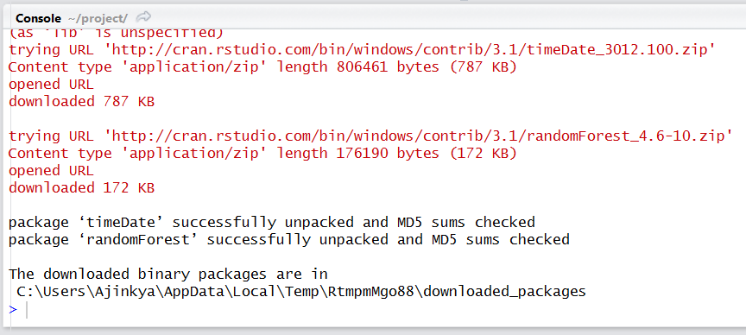

*Figure 13: Packages installed successfully*

* Wait for some time. The execution starts. This is a decision tree formation as shown in Figure:14

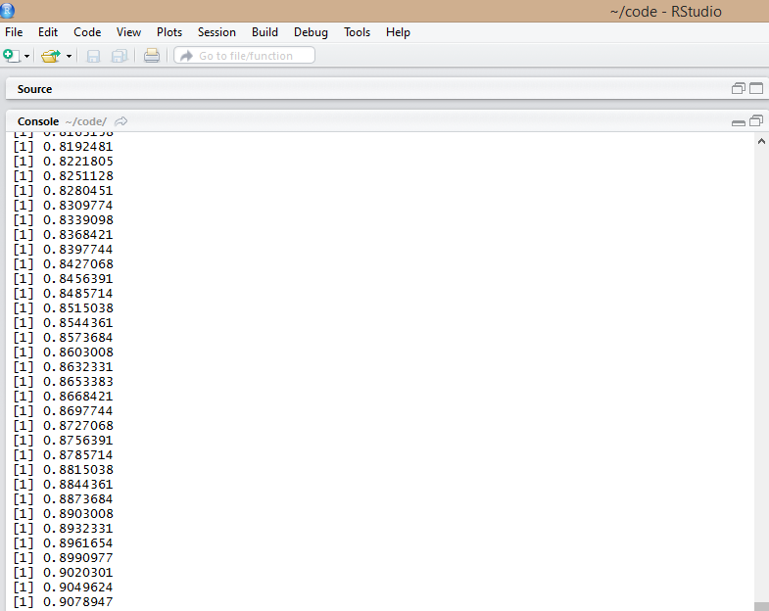

*Figure 14: Decision tree formation*

* Once the execution is completed look for the output in the final folder in the right down corner.
* Click on the final.csv where you will get the final output Figure:15



*Figure 15: Final output window*

# **References**

Breiman, L., Cutler, A., Liaw, A., & Wiener, M. (2015). Breiman and Cutler's random forests for classification and. *Package ‘randomForest’*.

code school. (n.d.). Retrieved from tryr.codeschool.com: http://tryr.codeschool.com/

Maimon, O., & Rokach, L. (n.d.). INTRODUCTION TO KNOWLEDGE DISCOVERY.

Murray, C., & Gardiner. (n.d.). In *Inquiring Organizations: Moving from Knowledge Management to Wisdom.*

Team, R. C., Wuertz, D., Setz, T., Chalabi, Y., Maechler, M., & Byers, J. W. (2015).

Rmetrics - Chronological and Calendar Objects. *Package ‘timeDate’*.

The R foundation. (n.d.). *The R Project for Statistical Computing*. Retrieved from r-project.org: http://www.r-project.org/

wikipedia. (2015, April 13). *Comma-separated values*. Retrieved from wikipedia.com: http://en.wikipedia.org/wiki/Comma-separated\_values

wikipedia. (2015, April 26). *Comma-separated values*. Retrieved from wikipedia.org: http://en.wikipedia.org/wiki/Comma-separated\_values

Wikipedia. (2015). *Random forest*. Retrieved from wikipedia.org: http://en.wikipedia.org/wiki/Random\_forest

wikipedia. (2015, March 5). *RStudio*. Retrieved from wikipedia.org: http://en.wikipedia.org/wiki/RStudio

Wikipedia. (2015, 5 3). *Rstudio*. Retrieved from wikipedia .org http://en.wikipedia.org/wiki/RStudio